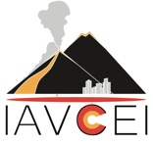**Nomination Form for IAVCEI**

**Volcanic Surveillance and Crisis Management award**

Supporters are required to answer the following four prompts about the nominee. Each response must not exceed 200 words in length. In total, no more than 2 pages (10 pt font size)

1. Please comment on the quality and impact of the nominated team's work as focal points for assessing volcanic hazard and risk and/or advancing monitoring strategies.
2. Please comment on the nominated team's contribution to eruption forecasts and crisis management.
3. Please comment on the capacity and impact of communication outreach of the nominated team in relation to volcanic hazards, volcanic risks and crisis management?

Supporter name:

Affiliation:

Email:

Date: