**Nomination Form 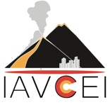for IAVCEI Collective Research Award**

Supporters are required to answer the following prompts about the nominee.

Each response must not exceed 200 words in length.

1. Please comment on the quality and impact of the nominated team's work as focal points for understanding volcanic activity in terms of originality, significance and rigour.
2. To what extent does the nominated team's work have made an impact on the volcanological scientific community at large (e.g. through scientific innovation, training development, multi- and inter-disciplinarity).
3. Please comment on how the nominated team's contribution reaches a broad or traditionally underrepresented audience and/or involved stakeholders (e.g. through new social practices that aim to meet social needs resulting from - for example - cooperation, inclusivity, education, community development, risk reduction or public health).

Supporter name:

Affiliation:

Email:

Date: