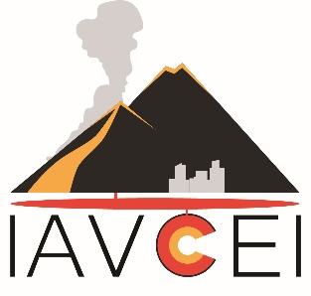
Continental Collision Zone Volcanism
and Associated Hazards
International Conference
YEREVAN, ARMENIA,
September 03-09, 2023
Expression of interest
First Name:
Second Name:
Country:
E-mail:
Telephone:
Comments
In Comments section please mention your preliminary interest to (I) participate in the conference, (II) to make a presentation, (III) to participate in post-conference trips and (IV) intention to attend the meeting together with an accompanying person.

Please return this form not later than 15th February 2023,
to volcanology2023@geology.am

