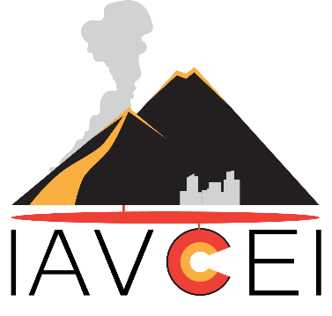

IAVCEI Commissions & Networks Annual Report and Plan for next year

Year reporting on: | e.g., 2022
Next year: | e.g., 2023

This document is intended to encourage Commission Leaders to reflect on their achievements over the past year and develop priorities and work plans for their Commissions for the coming year. It is not intended to be onerous to fill in! Please expand the boxes as needed.

Please email your completed report to one of the IAVCEI VPs by 15 December of the year you are reporting on. Reports may be shared with all Commission Leaders and/or the IAVCEI Exec.

Commission information

Commission Name
Commission Leader(s)
Names of any Deputy(s)/Advisory Group/Board/Exec members
How many members does your Commission have?

Is your Commission still active? If the answer is “No”, please indicate whether you have plans to rekindle activities, or whether the Commission can be discontinued.
Note that commissions may be discontinued at the discretion of the EC if the Commission guidelines have not been followed for 2 years.

Report on past year’s activities
This part of the report is based on the IAVCEI Commission Guidelines – please briefly comment on activities in each area.
Summarise your key activities over this past year, including any workshops, website development, meetings, newsletters, conference symposia, active social media pages...
Describe how you are incorporating Early Career Researchers in your leadership team and Commission activities.
When was your last election for Commission leadership, and who was elected? When do you plan to next hold elections? Note that leader(s) and any board of officers should be elected every 4 years (or every 2 years if desired).
Does your Commission have any active working groups? If so, please briefly describe their activities over the past year.
Comment on any issues/challenges

Commission Plan for next year

Please briefly comment on the objectives and plans for your Commission.
What are your key long-term objectives (next 3 years)?
What are your specific initiatives for the coming year?
Synergistic activities - do you have any activities planned that would be of interest to other Commissions? (If so please reach out to them in good time)

