Classifying calderas and re-examining paradigms

Shanaka de Silva
CEOAS, Oregon State University, Corvallis, OR, U.S.A.
desilvas@geo.oregonstate.edu

Classifications provide important conceptual frameworks for studies of calderas. These include the classic Williams and McBirney’s 1979 scheme based on volcano type and efforts to classify calderas by dominant composition or eruptive style (e.g Cole et al., 2000). For explosive silicic calderas, the most commonly used classifications are based on geological and geophysical studies of the structure of calderas that distinguish coherent versus non coherent collapse styles that Lipman (1997) has presented as a continuum with five end member geometic forms; piston, downsag, piecemeal, trap-door, and funnel. Most calderas exhibit evidence of some mixture of these endmembers. Such structural and morphological classifications focus on the effect but not the cause of caldera collapse.

The dominant paradigm for the cause of caldera collapse is underpressure created by eruption of a critical chamber volume fraction sufficient to trigger collapse (Figure 1. e.g Druitt and Sparks, 1984; Roche & Druitt, 2001; Geshi et al., 2014). Based on geological observations supported by theoretical and analog studies a two stage model where an initial overpressure conditions drives a central vent plinian eruption that transitions to an underpressured condition during which roof collapse along a ring fault occurs. However, the basis for this model is the concept of the “standard ignimbrite”. with the basal plinian fallout representing the over-pressured stage and the ignimbrite representing the caldera collapse. This transition is understood in terms of evolving vent conditions or water content that results changes in mass discharge rate and stability of the eruption column (Sparks and Wilson, 1976). A final paradigm is that overpressure is needed to initiate eruptions through dike propagation (e.g. Blake,, 1984; Tait et al., 1989). However, this is a model based on elastic rheology of reservoir bounding rocks, and recent work shows that this may not be tenable for situations where ductile rheologies dominate the boundaries of magma chambers (Jellinek and DePaolo, 2003; Gregg et al., 2012).

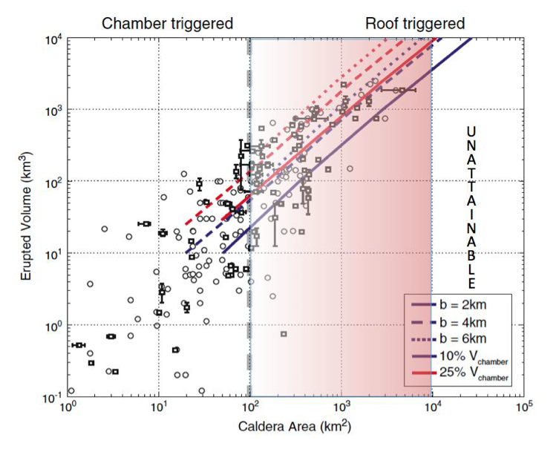
Instead, it is increasingly recognized that the largest calderas may not fit these “paradigm” limiting the application of the over-pressure/under-pressure model that holds sway. Observations in the western US, Yellowstone, Toba, and the largest Central Andean calderas indicate roof collapse initiates the eruption (e.g. Sparks et al., 1985; Christiansen, 2001; Chesner & Rose, 1991, de Silva et al., 2006). These studies are now supported by theoretical models that emphasize the thermomechanics of calderas (Jellinek and DePaolo, 2003. Gregg et al., 2012). In the Gregg et al model, while smaller systems may follow the prevailing two stage model, ductile wall rock rheologies around magma reservoirs >100 km³ may limit pressurization and allow uninterrupted magma reservoir growth until the roof founders into chamber initiating eruption. This leads to a thermomechanical division of calderas into smaller “brittle” systems that are triggered internally (bottom-up) and may follow the two stage model, while larger “ductile” systems are triggered externally (top-down). This mechanistic division might be coupled to the collapse style classifications through consideration of roof aspect ratio, where the larger systems involve incoherent plate subsidence while smaller systems may tend to more piston-like collapses, although such divisions are not necessarily rigid.
References Cited.
Blake, S. 1984. Jour. Geophys. Res. 89 (NB10): p.8237–8244.
Chesner, C A, and W I Rose. 1991. Bull. Volc. 53 (5). Springer: 343–56.
Christiansen, R. L., 2001. U.S.G.S Prof. Paper 729-G. USGS
Cole, J., Milner, D., and Spinks, K., 2005. Ear.-Sci. Rev. 69 (1-2), p. 1–26
de Silva, S.L. et al., 2006 Geol. Soc., London, Sp. Pub., 269. p.47-63
Druitt, T H, and Sparks. RSJ 1984. Nature 310 (5979). Nature Publishing Group: p. 679–81.
Geshi, N., Ruch J., and Acocella, V.,. 2014. Earth Planet. Sci. Letts. 396, p.107–15.
Gregg, P M, S L de Silva, E B Grosfils, and J P Parmigiani. 2012. Jour. Volcanol. Geotherm. Res 214-242. p.1–12.
Jellinek, A.M., and DePaolo, D.J., 2003. Bull. Volc. 65 (5), p.363–81.
Lipman, P. W. 1997. Bull. Volc. 59, p.198–218.
Roche, O., and Druitt., T.H., 2001. Earth Planet. Sci. Letts. 191 (3). p. 191–202.
Sparks, R S J, and L Wilson. 1976. Jour. Geol. Soc. Lond, 132 (4). p. 441–451.
Sparks, RSJ, et al.,. 1985. Jour. Volcanol. Geotherm. Res. 24 (3). p. 205–48.
Tait, S, Jaupart, C.,, and Vergniolle, S.,. 1989. Earth Planet. Sci. Letts 92: 107–23.
Williams H, McBirney AR (1979) Volcanology. Freeman, Cooper and Co, San Francisco

